A. Assignment Information
Particular | Details
Department | COMPUTER SCIENCE ENGINEERING
Programme | B.E/B.TECH
Course Code & Course Name | CSA1607 – Data Warehousing and Data Mining
Academic Year / Batch | 2022/
Faculty Name | Dr. Beulah David
Assignment Title | Climate-Smart Farm Intelligence for Indian Agriculture: Predicting Crop Stress, Yield Risk and Water Resource Priorities
Date of Issue | 31-08-2026
Date of Submission | 31-08-2026
Maximum Marks | 100
Course Outcome(s) – CO | CO1, CO2, CO3
Bloom’s Taxonomy Level | L3 – Apply | L4 – Analyze | L5 – Evaluate | L6 – Create
Individual Student | Chandrashekar S - 192372163

B. Assignment Problem / Challenge
The assignment addresses a real-world agricultural decision-support problem in which weather, soil, crop, irrigation, pest and historical-yield information is fragmented across heterogeneous sources. The supplied challenge asks for an integrated Data Warehouse and Data Mining framework that can transform these sources into actionable intelligence rather than stopping at conventional yield prediction.
The central objective of the implementation is to predict crop-stress and yield-loss risk 7–14 days in advance, identify the major factors contributing to risk, and prioritize limited agricultural resources such as irrigation support, field inspection, pest surveillance and expert advisory services.
The project is implemented as an individual coding-based prototype. The implementation uses a reproducible synthetic dataset so that the complete ETL, warehouse, OLAP, machine-learning and dashboard pipeline can be demonstrated offline. The synthetic data are not presented as field-validated agricultural measurements.

C. Problem Statement
Indian agriculture is increasingly affected by unpredictable rainfall, prolonged dry spells, rising temperatures, reduced soil moisture and inefficient allocation of irrigation resources. Region-level advisories can be insufficient because farms within the same district may experience different crop stress depending on soil conditions, rainfall received, growth stage and irrigation access. The assignment therefore frames the problem as an integrated, explainable decision-support task.
Problem Formulation: Given heterogeneous farm-level observations, construct a warehouse-centric analytical pipeline that (1) integrates and cleans the data, (2) derives risk indicators, (3) predicts high-risk versus low-risk farms for the near future, (4) explains the important factors, and (5) converts the result into prioritized resource-allocation decisions.
Target question: “Can an integrated agricultural Data Warehouse and Data Mining system predict where crop stress is likely to occur, explain why the risk is emerging, and determine which farms or agricultural zones should receive intervention first?”

D. Requirements and Constraints
Requirement / Constraint | Assignment Requirement | Project Implementation
Functional requirements | ETL, warehouse, OLAP, risk index, 3 classifiers, evaluation, dashboard | Implemented as a Python + SQLite + Streamlit pipeline.
Data integration | Integrate heterogeneous spatial-temporal agricultural data | Seven logical CSV sources linked through farm_id and normalized into analytical features.
Preprocessing | Cleaning, transformation, reduction and discretization | Numeric coercion, median filling, standardized categories, engineered deviations/bands, reduced analytical column set.
OLAP | Roll-up, Drill-down, Slice, Dice and Pivot | Implemented as Python functions in olap.py and exposed in dashboard roll-up/pivot views.
Risk index | Use rainfall, moisture, temperature, stage, irrigation and pest factors | 0–100 weighted Farm/Crop Risk Index.
Predictive models | At least three classification algorithms | Decision Tree, Naïve Bayes and SVM.
Validation | Accuracy, Precision, Recall, F1, Confusion Matrix and Cross-validation | 20% stratified hold-out test set plus 5-fold cross-validation.
Safety / ethics | Investigate false positives/negatives and uncertainty; avoid unsafe deployments | Synthetic data, controlled offline prototype, no real irrigation actuation.
Technical constraints | Practical implementation using modern tools | Python 3.10+, pandas, NumPy, scikit-learn, SQLite, Streamlit, Plotly and Matplotlib/Seaborn.

E. Student Work

1. Problem Understanding and Formulation
The problem was converted into a farm-level early-warning workflow. Each farm record is treated as the analytical grain, while geography, crop/season and observation context are represented through dimensions and feature columns. The system first consolidates the fragmented inputs and then applies analytical methods to identify high-risk farms.
The implementation intentionally separates descriptive/OLAP analysis from predictive modelling. OLAP answers where risk is concentrated by state, district and crop, whereas the classifiers learn the binary risk label from the engineered predictors. This separation reduces the risk of accidentally leaking future outcomes into the prediction model.

2. Objectives and Expected Outcomes
- Build a multidimensional agricultural data warehouse from heterogeneous source datasets.
- Clean, transform, integrate, reduce and discretize the input data.
- Perform Roll-up, Drill-down, Slice, Dice and Pivot analysis to identify spatial and crop-specific risk patterns.
- Develop a 0–100 Farm/Crop Risk Index from rainfall deviation, soil-moisture deficit, temperature anomaly, growth stage, irrigation gap and pest incidence.
- Build and compare Decision Tree, Naïve Bayes and SVM classifiers.
- Evaluate the models using Accuracy, Precision, Recall, F1-score, confusion matrix and 5-fold cross-validation.
- Explain why individual farms are at risk and convert predictions into prioritized interventions.
- Provide an early-warning dashboard that answers WHERE, WHICH, WHY, HOW SEVERE and WHAT NEXT.

3. Application of Relevant Course Knowledge / Concepts
- Data Warehousing: fact and dimension modelling, ETL, indexing and analytical grain.
- OLAP: aggregation and multidimensional exploration through roll-up, drill-down, slice, dice and pivot operations.
- Data Preprocessing: type conversion, missing-value treatment, feature engineering and discretization.
- Data Mining: supervised classification for crop-stress / yield-risk assessment.
- Model Evaluation: stratified hold-out validation and 5-fold cross-validation with class-sensitive metrics.
- Decision Support: translation of analytics into intervention priorities for irrigation, inspection, pest monitoring and advisory services.
- Explainable Analytics: feature importance and factor-level evidence for individual farms.

4. Solution / Design / Methodology
The proposed architecture follows a layered analytics pipeline. Heterogeneous CSV sources are extracted and standardized in ETL, loaded into a SQLite star-schema warehouse, transformed into a modelling dataset, passed to the Risk Index and classification modules, and finally exposed through a Streamlit dashboard. The assignment requires integrated ETL and an appropriate star/snowflake schema; this implementation uses a compact star-schema design.

Block Diagram of the Proposed System
HETEROGENEOUS SOURCES
Weather | Soil Moisture | Farm/Crop | Irrigation | Pest | Historical Yield
ETL LAYER
Extract → Clean → Integrate → Transform → Reduce → Discretize
AGRICULTURAL DATA WAREHOUSE
Dim Farm | Dim Geography | Dim Crop | Dim Date | Fact Farm Risk
OLAP ANALYSIS
Roll-up | Drill-down | Slice | Dice | Pivot
FEATURE ENGINEERING
Rainfall Deviation | Moisture Deficit | Temperature Anomaly | Irrigation Gap | Pest
FARM/CROP RISK INDEX
0–100 score → Low / Moderate / High / Critical
MACHINE LEARNING
Decision Tree | Naïve Bayes | SVM
EXPLAINABLE DECISION SUPPORT
Risk drivers + intervention priority
STREAMLIT EARLY WARNING DASHBOARD
WHERE | WHICH | WHY | HOW SEVERE | WHAT ACTION

Star Schema
DIM_FARM | FACT_FARM_RISK | DIM_GEOGRAPHY
farm_id  latitude  longitude | farm_id  geography_id  crop_id  risk_label  weather / soil / irrigation / pest measures | geography_id  state  district
DIM_CROP | FACT_FARM_RISK | DIM_DATE
crop_id  crop  season | fact measures and target | date_id  calendar date  year / month
The fact table stores the measurable risk-related values and target, while the dimension tables provide farm, geography, crop/season and date context. This supports multidimensional analysis without duplicating descriptive attributes in every fact row.

5. Algorithm / Pseudocode / Flowchart

Algorithm A – ETL and Warehouse Loading
- Load the seven source CSV datasets.
- Normalize text fields and convert numeric columns to numeric types.
- Fill missing numeric values using the column median.
- Merge sources using farm_id and season.
- Compute rainfall deviation, soil-moisture deficit, temperature anomaly and yield-loss percentage.
- Discretize selected variables into interpretable bands.
- Reduce the dataset to analytical columns and save integrated_features.csv.
- Populate the dimension tables and fact_farm_risk table in SQLite.

Algorithm B – Farm/Crop Risk Index
For each farm:
rainfall_risk = normalized(max(-rainfall_deviation, 0))
moisture_risk = clip(soil_moisture_deficit, 0, 1)
temperature_risk = normalized(max(temperature_anomaly, 0))
stage_risk = growth_stage / 4
irrigation_risk = clip(irrigation_gap_days / 14, 0, 1)
pest_risk = clip(pest_incidence / 10, 0, 1)
RiskIndex = 100*(0.20*rainfall_risk +
0.25*moisture_risk +
0.15*temperature_risk +
0.10*stage_risk +
0.20*irrigation_risk +
0.10*pest_risk)
0–25 -> Low
25–50 -> Moderate
50–75 -> High
75–100 -> Critical

Algorithm C – Classification and Evaluation
- Select non-leaking predictors: state, district, crop, season, growth stage, rainfall deviation, soil-moisture deficit, temperature anomaly, irrigation gap, irrigation availability, pest incidence and historical yield.
- Split the data into 80% training and 20% testing using stratification.
- Preprocess categorical variables using one-hot encoding and numeric variables using median imputation and standardization.
- Train Decision Tree, Naïve Bayes and SVM models.
- Compute Accuracy, Precision, Recall and F1 on the hold-out test set.
- Run 5-fold Stratified Cross-validation to estimate stability.
- Select the model with the strongest test-set F1 for the prototype and examine false negatives using the confusion matrix.

Key Implementation Snippets
# Risk index
df["risk_index"] = 100*(
.20*df["rainfall_risk"] + .25*df["moisture_risk"] +
.15*df["temperature_risk"] + .10*df["stage_risk"] +
.20*df["irrigation_risk"] + .10*df["pest_risk"]
)
# Model set
models = {
"Decision Tree": DecisionTreeClassifier(class_weight="balanced", ...),
"Naive Bayes": GaussianNB(),
"SVM": SVC(kernel="rbf", class_weight="balanced", probability=True)
}
# OLAP operations
roll_up_by_state()
drill_down_by_district(state)
slice_crop(crop)
dice(crops, seasons)
pivot_crop_by_state()

6. Implementation / Source Code and Environment / Tools Used
Tool / Technology | Purpose in the Project
Python 3.10+ | Core implementation, ETL, modelling, scoring and orchestration.
pandas | Data loading, cleaning, transformation, aggregation and table preparation.
NumPy | Numerical operations and risk-score calculations.
scikit-learn | Preprocessing, Decision Tree, Naïve Bayes, SVM, cross-validation and metrics.
SQLite | Lightweight relational Data Warehouse implementation.
Streamlit | Interactive early-warning dashboard.
Plotly | Interactive dashboard visualizations.
Matplotlib / Seaborn | Confusion matrix, risk distribution and feature-importance plots.
VS Code / Terminal | Development and execution environment.
Source-code package: generate_data.py, etl.py, olap.py, mining.py, app.py, requirements.txt and supporting data/warehouse/output folders. The complete runnable package accompanies this report.

7. Results and Validation
The following outputs are taken from the completed project and the supplied dashboard screenshots. The screenshots are retained as execution evidence and are followed immediately by an observation, following the organization of the sample report.

Output 1 – Early Warning Dashboard
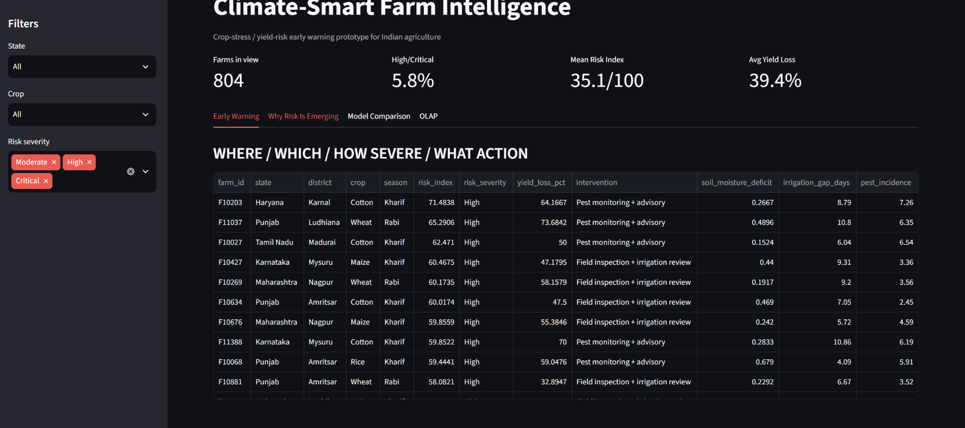
Output 1 – Early Warning Dashboard
Observation: The dashboard shows the default filtered view with 804 farms in view, 5.8% High/Critical, mean Risk Index 35.1/100 and average yield loss 39.4%. Because the severity filter excludes Low-risk farms by default, these KPIs describe the selected dashboard view rather than the complete dataset.

Output 2 – Weather / Soil Risk Feature Space
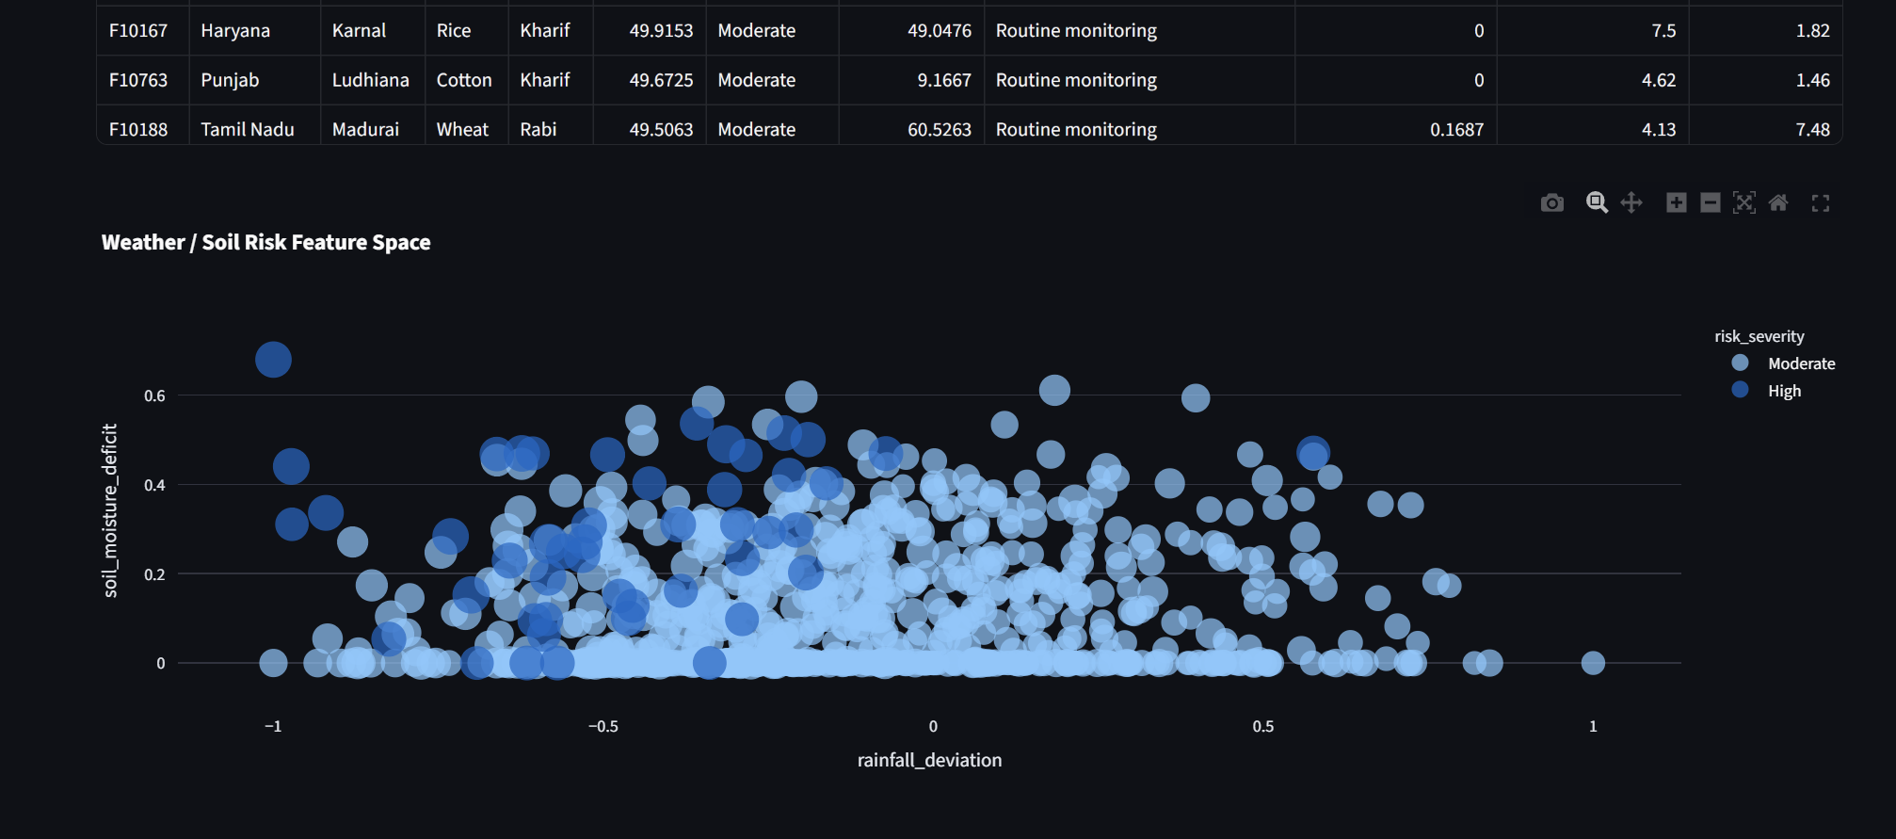
Output 2 – Weather / Soil Risk Feature Space
Observation: The scatter plot relates rainfall deviation to soil-moisture deficit, with point size representing Risk Index and point categories representing risk severity. The view helps identify regions of combined rainfall and moisture stress.

Output 3 – Why Risk Is Emerging
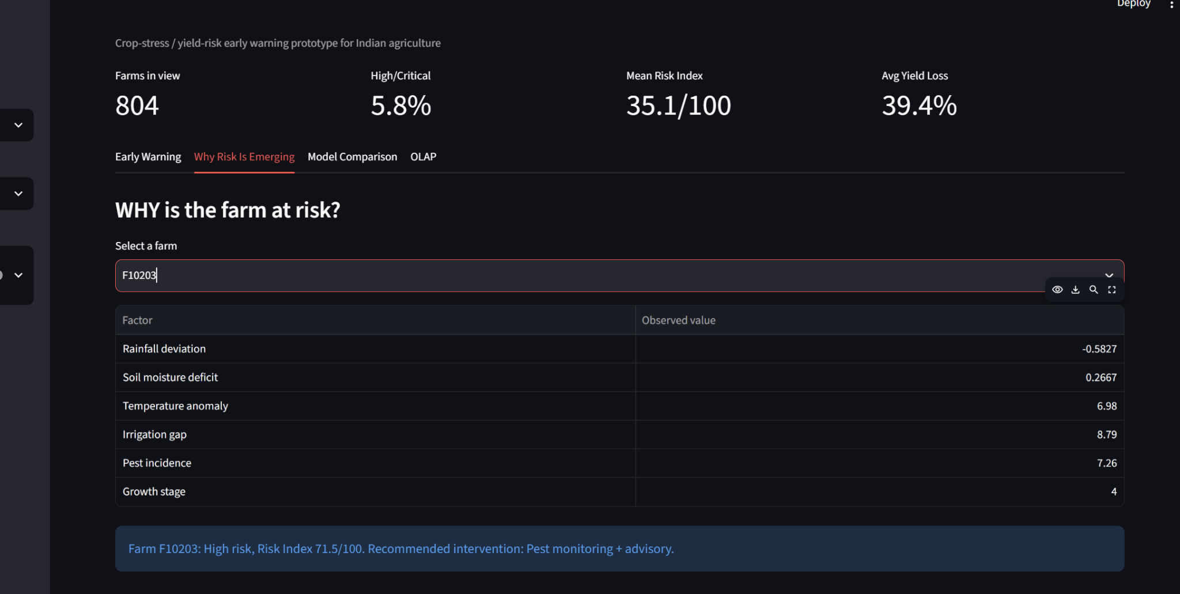
Output 3 – Explainable Farm Risk View
Observation: For the selected farm F10203, the dashboard exposes rainfall deviation (-0.5827), soil-moisture deficit (0.2667), temperature anomaly (6.98), irrigation gap (8.79 days), pest incidence (7.26) and growth stage 4. The dashboard classifies it as High risk with a Risk Index of 71.5/100 and recommends pest monitoring plus advisory.

Output 4 – Classification Model Comparison
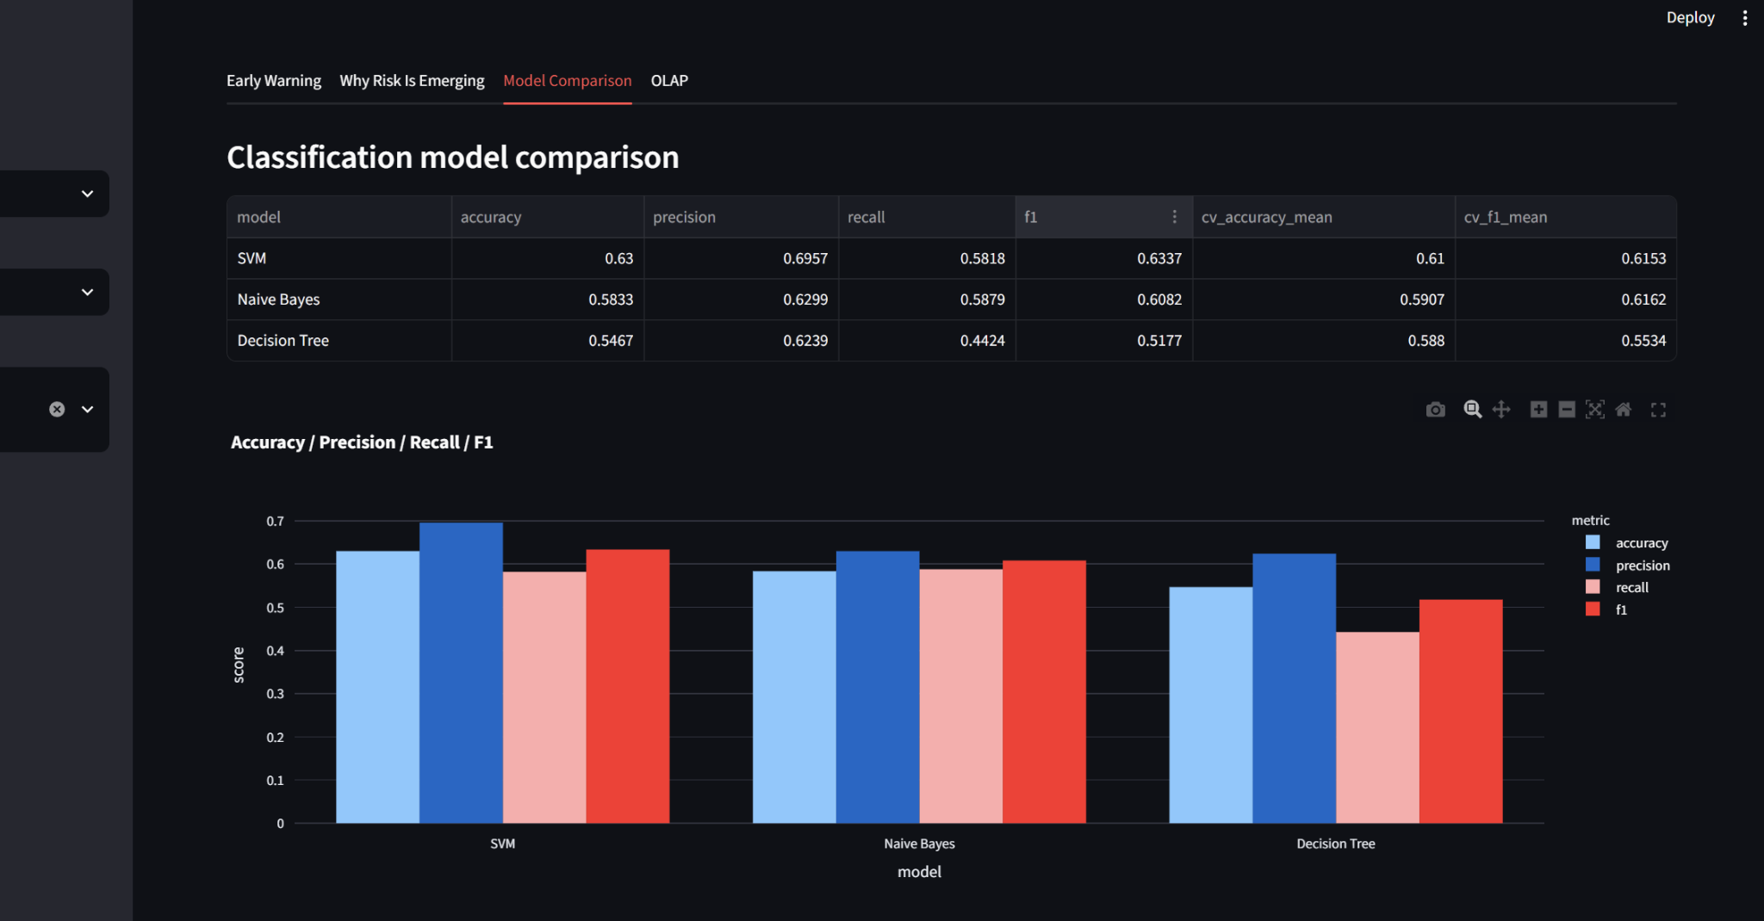
Output 4 – Model Comparison
Observation: The evaluation compares SVM, Naïve Bayes and Decision Tree using Accuracy, Precision, Recall and F1. SVM has the strongest hold-out F1 (0.6337), while Naïve Bayes has a marginally higher mean cross-validation F1 (0.6162 versus 0.6153 for SVM).

Output 5 – OLAP State Roll-up and State × Crop Pivot
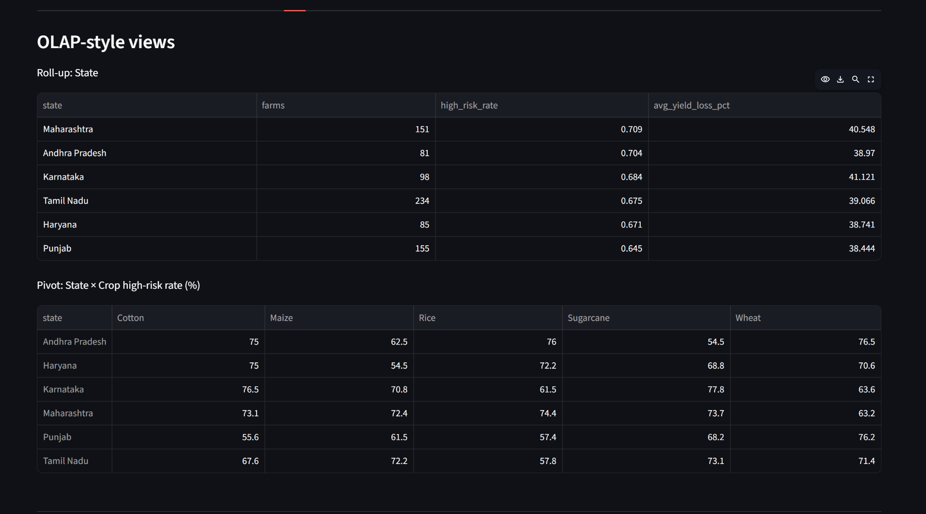
Output 5 – OLAP Analysis
Observation: The roll-up aggregates farm count, high-risk rate and average yield loss by state. The pivot view compares high-risk rates across State × Crop combinations. In the displayed filtered view, Maharashtra has the highest high-risk rate among the shown states at 70.9%, followed by Andhra Pradesh at 70.4%.

Output 6 – Confusion Matrix for Selected Model
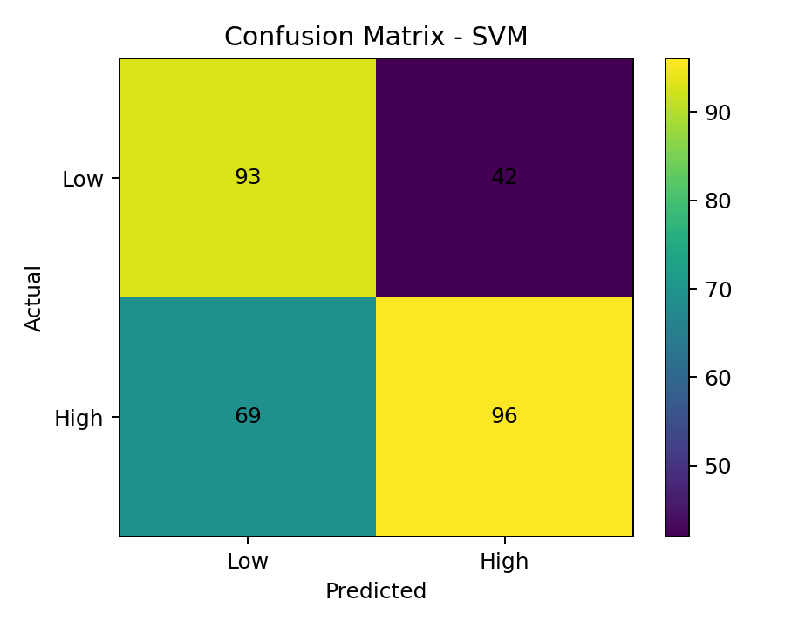
Output 6 – SVM Confusion Matrix
Observation: The SVM confusion matrix contains 93 true negatives, 42 false positives, 69 false negatives and 96 true positives. The 69 false negatives are particularly important because they represent genuinely high-risk farms that the model would fail to flag.

Validation Metrics Table
Model | Accuracy | Precision | Recall | F1 | CV Accuracy | CV F1
SVM | 0.6300 | 0.6957 | 0.5818 | 0.6337 | 0.6100 | 0.6153
Naïve Bayes | 0.5833 | 0.6299 | 0.5879 | 0.6082 | 0.5907 | 0.6162
Decision Tree | 0.5467 | 0.6239 | 0.4424 | 0.5177 | 0.5880 | 0.5534
Model selection: SVM is selected as the prototype model because it produces the best hold-out F1-score (0.6337). However, the cross-validation results show that Naïve Bayes has a slightly higher mean CV F1-score (0.6162), so the result should be described as dataset- and metric-dependent rather than universally superior.

Output 7 – Decision Tree Feature Importance
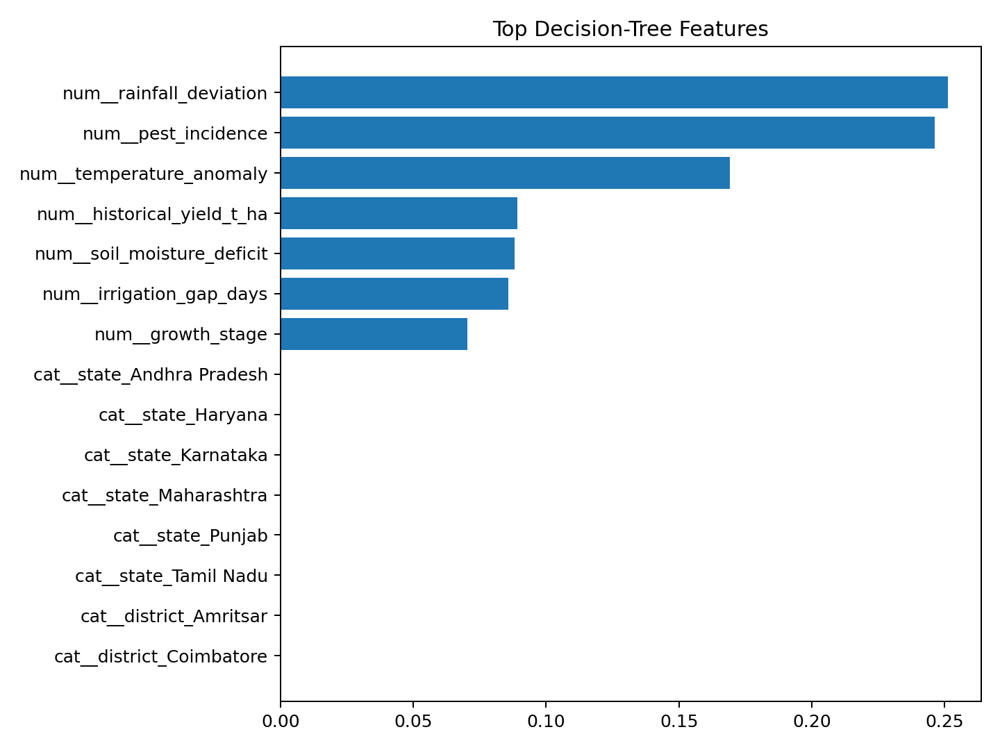
Output 7 – Feature Importance for Explainability
Observation: The Decision Tree identifies rainfall deviation as the strongest feature, followed by pest incidence and temperature anomaly. Historical yield, soil-moisture deficit, irrigation gap and growth stage also contribute to the decision process. This supports the dashboard’s factor-level explanation of emerging risk.

Validation Test Cases
Test | Input / Scenario | Expected Result | Observed / Status
TC-01 | Run generate_data.py | Seven source datasets generated | PASS
TC-02 | Run etl.py | Integrated features and SQLite warehouse created | PASS
TC-03 | Run olap.py | State roll-up output displayed | PASS
TC-04 | Run mining.py | Three models trained and metrics produced | PASS
TC-05 | View dashboard with default filters | Risk table and feature-space chart displayed | PASS
TC-06 | Select a high-risk farm | Drivers and intervention displayed | PASS
TC-07 | Inspect model evaluation | Accuracy/Precision/Recall/F1/CV shown | PASS
TC-08 | Inspect confusion matrix | False positives and false negatives visible | PASS
TC-09 | Inspect OLAP tab | State roll-up and State × Crop pivot displayed | PASS
TC-10 | Check source-code compilation | Python files compile successfully | PASS

8. Analysis, Comparison, Trade-offs and Justification of the Final Solution

Model Comparison
The SVM achieved the best hold-out F1-score of 0.6337 and the highest hold-out accuracy of 0.6300. Its precision of 0.6957 is the highest among the three models, which indicates that a large fraction of farms predicted as high-risk were actually high-risk in the test set. Naïve Bayes has slightly stronger hold-out recall than SVM (0.5879 versus 0.5818) and a marginally better cross-validation F1 mean (0.6162 versus 0.6153). The Decision Tree is easiest to interpret structurally, but it has the lowest recall and F1 in this experiment.

False Positives versus False Negatives
The SVM confusion matrix contains 42 false positives and 69 false negatives. For agricultural early warning, false negatives are operationally more concerning because a missed high-risk farm may not receive timely intervention. This justifies paying explicit attention to recall and F1 rather than selecting a model solely by accuracy, consistent with the assignment’s emphasis on the consequences of missing genuinely high-risk farms.

Risk Index versus Predictive Model
The Risk Index is a transparent, rule-weighted decision score, whereas the classifiers are learned predictive models. The Risk Index is useful for immediate prioritization and explanation because every component has an explicit contribution. The classifier can potentially capture nonlinear or interacting relationships that are not represented directly in the weighted formula. Using both provides a hybrid decision-support design: the Risk Index provides interpretability and prioritization, while the classifier provides predictive comparison.

Key Trade-offs
Design Choice | Advantage | Trade-off / Limitation
SQLite warehouse | Lightweight, reproducible, zero server administration | Not intended for high-concurrency production workloads.
Synthetic prototype data | Fully reproducible and safe for offline demonstration | Does not establish field-level predictive validity.
Weighted Risk Index | Transparent and easy to explain | Weights are expert-designed for the prototype and require field calibration.
SVM | Strong hold-out F1 and precision in the prototype | Less directly interpretable than a shallow Decision Tree.
Decision Tree explanation | Human-readable variable importance | Lower predictive performance in this run.
Class weighting | Reduces the tendency to ignore minority risk cases | Can increase false positives and should be calibrated with operational cost.
Streamlit dashboard | Fast development and clear interactive evidence | Not a substitute for enterprise-grade authentication, deployment and monitoring.

Justification of the Final Solution
The final solution is justified because it covers the complete analytical chain required by the assignment: heterogeneous-data integration, warehouse modelling, OLAP analysis, a novel risk index, three predictive models, evaluation, explainability and resource prioritization. The implementation also separates future-outcome variables from model predictors to reduce obvious target leakage. The dashboard translates technical outputs into decisions that an agricultural support centre could operationally understand.

9. Broader Considerations / SDG Relevance
The supplied assignment maps the problem to SDG 2 – Zero Hunger, SDG 6 – Clean Water and Sanitation, SDG 8 – Decent Work and Economic Growth, SDG 9 – Industry, Innovation and Infrastructure, SDG 12 – Responsible Consumption and Production, and SDG 13 – Climate Action.
- SDG 2 – Zero Hunger: earlier identification of crop stress can support timely farm-level intervention and potentially reduce avoidable yield loss.
- SDG 6 – Clean Water and Sanitation: irrigation prioritization can direct scarce water resources to farms with the greatest moisture/irrigation need.
- SDG 8 – Decent Work and Economic Growth: protecting farm productivity supports agricultural livelihoods and resource-efficient operations.
- SDG 9 – Industry, Innovation and Infrastructure: the project demonstrates an integrated data platform combining heterogeneous sources, warehouse storage, analytics and visualization.
- SDG 12 – Responsible Consumption and Production: resource prioritization reduces indiscriminate intervention and supports more targeted agricultural inputs.
- SDG 13 – Climate Action: rainfall anomalies, temperature anomalies and soil-moisture stress are explicitly represented in the risk pipeline.

Ethical, Privacy and Professional Considerations
- The prototype does not control physical irrigation infrastructure or apply chemicals automatically; decisions remain advisory.
- Synthetic data are used to avoid exposing real farmer identities or sensitive farm records.
- Model uncertainty and false negatives should be communicated rather than presenting the classifier as infallible.
- Spatial bias can occur if some regions have much better sensor coverage than others; production deployment would require coverage diagnostics.
- Data leakage must be continuously monitored, especially when future yield or post-season measurements are available in integrated sources.

10. Conclusion, Limitations and Possible Improvements
The Climate-Smart Farm Intelligence prototype successfully demonstrates an integrated Data Warehousing and Data Mining workflow for agricultural risk decision support. The system consolidates heterogeneous source data, loads a star-schema SQLite warehouse, supports OLAP analysis, computes a Farm/Crop Risk Index, compares three classifiers, evaluates predictive performance, explains important drivers and prioritizes interventions through an interactive dashboard.

Limitations
- The bundled dataset is synthetic and therefore cannot establish real-world agricultural accuracy.
- The Risk Index weights are designed for the prototype and require empirical calibration with agronomists and field outcomes.
- The current prototype uses a single observation snapshot rather than a truly streaming spatio-temporal data pipeline.
- The dashboard uses feature-space plots instead of a geospatial map with verified farm coordinates and real satellite layers.
- Uncertainty calibration, probability calibration and external validation on unseen regions are not yet implemented.

Possible Improvements
- Integrate verified Indian weather, soil and crop datasets and document provenance and licensing.
- Add satellite-derived vegetation indices and time-series features.
- Use temporal validation and regional hold-out validation to test generalization.
- Add SHAP or similar model-agnostic explanations and calibrated probabilities.
- Add a production warehouse such as PostgreSQL and role-based dashboard access.
- Add a geospatial map layer and resource-capacity constraints so the prioritization engine can allocate limited intervention teams or irrigation slots explicitly.

11. One-Page Individual Reflection
This assignment helped me understand how Data Warehousing and Data Mining concepts can be combined into a practical decision-support system instead of being implemented as isolated classroom exercises. I learned that the quality of a mining result depends strongly on the structure and preparation of the underlying data. Building the ETL layer made this clear because weather, soil, crop, irrigation, pest and historical-yield sources do not naturally arrive in a single clean analytical table.
A major learning outcome was understanding the role of the warehouse in supporting both reporting and mining. The star-schema structure made it possible to think in terms of an analytical grain and dimensions, while the OLAP functions showed how the same integrated data can be viewed at state, district and crop levels. The Risk Index then introduced a decision-oriented layer on top of the warehouse rather than treating data mining as an isolated prediction problem.
The model-comparison stage improved my understanding of evaluation metrics. Accuracy alone does not capture the operational cost of missing high-risk farms. The confusion matrix showed that false negatives can be substantial even when overall accuracy appears reasonable. This made Recall and F1-score more meaningful for the agricultural warning context. I also learned that cross-validation can tell a slightly different story from a single hold-out test set, which is why model selection should consider stability and the intended decision cost.
Implementing the Streamlit dashboard was another important learning experience because it required converting model outputs into information that a user can act on. A prediction such as “High Risk” is less useful than a result that also shows the main drivers and recommends an intervention such as irrigation review or pest surveillance. This reinforced the idea that analytics systems should be designed around decisions and users, not only algorithms.
The main limitation of my current implementation is the use of synthetic data. With more time, I would integrate real Indian agricultural datasets, add temporal and geospatial features, validate the system across unseen districts, calibrate the Risk Index with expert input, and extend the dashboard with a real map and stronger uncertainty reporting. Overall, the assignment strengthened my practical understanding of ETL, warehouse design, OLAP, preprocessing, classification, evaluation and explainable decision support in one integrated workflow.

12. Individual Contribution
S.No | Reg No. | Name / Contribution
1 | 192372163 | Chandrashekar S. – The assignment was completed individually. I handled problem formulation, dataset design, ETL pipeline, data warehouse/star schema, OLAP operations, Risk Index design, Decision Tree/Naïve Bayes/SVM implementation, evaluation, dashboard development, testing, analysis, documentation and final report preparation.

13. References

[1] J. Han, J. Pei, and H. Tong, Data Mining: Concepts and Techniques, 4th ed.

Cambridge, MA, USA: Morgan Kaufmann, 2022.

[2] P. Ponniah, Data Warehousing Fundamentals: A Comprehensive Guide for

IT Professionals, 2nd ed. Hoboken, NJ, USA: Wiley, 2010.

[3] R. Kimball and M. Ross, The Data Warehouse Toolkit: The Definitive Guide

to Dimensional Modeling, 3rd ed. Indianapolis, IN, USA: Wiley, 2013.

[4] U. M. Fayyad, G. Piatetsky-Shapiro, and P. Smyth, “From data mining to

knowledge discovery in databases,” AI Magazine, vol. 17, no. 3,

pp. 37–54, 1996.

[5] I. H. Witten, E. Frank, M. A. Hall, and C. J. Pal, Data Mining: Practical

Machine Learning Tools and Techniques, 4th ed. Cambridge, MA, USA:

Morgan Kaufmann, 2016.

[6] C. M. Bishop, Pattern Recognition and Machine Learning.

New York, NY, USA: Springer, 2006.

[7] T. Hastie, R. Tibshirani, and J. Friedman, The Elements of Statistical

Learning: Data Mining, Inference, and Prediction, 2nd ed.

New York, NY, USA: Springer, 2009.

[8] F. Pedregosa et al., “Scikit-learn: Machine learning in Python,”

Journal of Machine Learning Research, vol. 12, pp. 2825–2830, 2011.

[9] T. Fawcett, “An introduction to ROC analysis,” Pattern Recognition

Letters, vol. 27, no. 8, pp. 861–874, 2006.

[10] Food and Agriculture Organization of the United Nations, The State of

Food and Agriculture 2021: Making Agrifood Systems More Resilient to

Shocks and Stresses. Rome, Italy: FAO, 2021.

[11] Food and Agriculture Organization of the United Nations, The State of

Food and Agriculture 2022: Leveraging Automation in Agriculture for

Transforming Agrifood Systems. Rome, Italy: FAO, 2022.

[12] Intergovernmental Panel on Climate Change, Climate Change 2022:

Impacts, Adaptation and Vulnerability. Cambridge, U.K.:

Cambridge University Press, 2022.

[13] W. McKinney, Python for Data Analysis: Data Wrangling with pandas,

NumPy, and Jupyter, 3rd ed. Sebastopol, CA, USA: O’Reilly Media, 2022.

[14] Streamlit Inc., “Streamlit documentation,” 2024. [Online].

Available: https://docs.streamlit.io/

[15] Plotly Technologies Inc., “Plotly Python documentation,” 2024.

[Online]. Available: https://plotly.com/python/

14. CO–Assessment Mapping (Student-Side)
CO | Focus | Implementation Evidence | Assessment Evidence
CO1 | Multidimensional agricultural warehouse | Star schema, fact table, dimensions, ETL and SQLite database | Warehouse schema, ETL code and OLAP outputs
CO2 | Preprocessing and feature engineering | Cleaning, integration, reduction, discretization and engineered risk variables | Integrated feature table, Risk Index and feature analysis
CO3 | Predictive mining and decision support | Decision Tree, Naïve Bayes, SVM, evaluation and intervention prioritization | Model metrics, confusion matrix, dashboard and analysis
The supplied assignment specifies CO1, CO2 and CO3 and Bloom levels L3–L6. Any official PO mapping should be finalized by the faculty according to the programme-level mapping, rather than inferred in the student report.

15. Assessment Structure / Rubric Alignment
Assessment Component | Report Evidence
Problem understanding & formulation | Sections B–E1
Application of course/domain knowledge | E2–E4
Solution / design / implementation | Architecture, algorithms and source code description
Modern tool usage | Implementation tools table and project package
Results, testing & validation | Outputs 1–7 and test-case table
Analysis, trade-offs & justification | Section 8
Broader considerations / professional responsibility | Section 9
Documentation & reflection | Sections 11–13

16. Faculty Evaluation & Continuous Improvement (for Faculty Use)
Target CO Attainment: __________________________________________
Actual CO Attainment: ___________________________________________
Faculty Analysis: ________________________________________________
Areas requiring improvement: ______________________________________
Corrective / Improvement Action: _________________________________
Action to be implemented in the next offering: _____________________

Documents to be Maintained
- Assignment question / problem statement
- CO–Assessment mapping and assessment rubric
- Student source-code package and execution evidence
- Evaluated report and scripts
- Marks and rubric-wise assessment
- CO attainment analysis and continuous-improvement action

